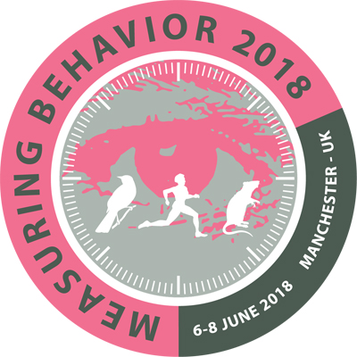MB2018 Style Guide

Introduction
Submissions for posters and papers (in general sessions and in symposia) must follow this style guide. If accepted, your paper will be published in the Conference Proceedings. Abstracts for tutorials, demonstrations, workshop proposals, and symposium proposals can be in free text.
File format
You can submit your document in any Microsoft Word format. If you are unable to create documents in that format, please contact the conference organization. Figures should either be embedded in the text, or enclosed as jpeg files.
Language
The conference language is English. It is the responsibility of the authors to write correct clear English, the conference organization will not edit the abstracts. Active (not passive) voice is preferred and the text should be comprehensible for participants for whom English is not their first language, and are from other scientific disciplines. If the standard of the English of the abstract is insufficient, it will be returned to the author to be rewritten. You may use any English dialect (US, British, etc), as long as it is consistent. Briefly define or explain all technical or specialist terms that may be unfamiliar to all readers.
Length of abstracts
Because of the multi-disciplinary nature of the conference, we are flexible about the length of abstracts required. They must be long enough so that reviewers can judge the quality of your presentation (at least one page not including figures, about 500 words) but you may also submit a short paper of 7 pages (not including figures and tables, about 4000 words) if you wish. Abstracts for posters, symposia proposals, workshops, tutorials, and demonstrations should be about 1 page long.
Ethical statement
If your work presented at Measuring Behavior includes experiments on animals or suffering to human subjects, please include a statement indicating which authorized ethical committee has approved the experiments. The methods should be described in sufficient detail to allow assessment of the standard of welfare concerning the research’s subjects. The paper will not be accepted if it does not meet these criteria.
Content
It is important that you write for the Measuring Behavior audience. Take a look at previous abstracts on measuringbehavior.org. Remember to focus on methods and techniques and not on results. Write for a multi-disciplinary audience. Your abstract will not be accepted if it does not meet those criteria. The contents of your paper must not have been previously published in a journal or other conference proceedings. However, it is possible to mention previously published results (with citation) so long as your focus in this paper is on the methodology, with new information about that aspect.
How to use this document to create your abstract
The exact procedure may differ slightly, depending on your version of Word:
- Save this document to your hard disk, if necessary enable editing.
- Make a copy, so that you can read the style guidelines later.
- Open one copy in Microsoft Word.
- Delete all the text and picture (logo) in this document before you start writing.
- As you write your text, apply the relevant styles. There are 6 styles embedded in this document (MB Title, MB sub-title, MB Authors, MB Affiliation, MB body text and MB Caption). The styles are defined at the end of this document. To apply a style to the currently selected text, click on the style name in the Home ribbon.
- Save the document.
- Submit the document as indicated on the following web page: http://www.measuringbehavior.org/mb2016/submission
Styles
The Title should be in Times New Roman, centered, 13 pt, bold. Use Title Capitalization. Style name in this document is MB Title
Authors (do not enter until after paper is accepted)
Style: 10 pt, centered. Style in this document is MB Authors.
Example: L.Z. Smith¹, P.T. Clayton² and E. Johnson¹
Affiliation (do not enter until after the paper is accepted)
(Institute/Department, University/Company, City, Country; no street address or postal code. e-mail)
Style: 9 pt, bold, centered. Style in this document is MB Affiliation
Example: 1Department of Psychology, University of Lisbon, Lisbon, Portugal. lsmith@mail.com
Sub-titles should be in Times New Roman, 12 pt, bold, left justified. Style name in this document is MB sub-title. Use sentence capitalization.
Body text (including table text) should be in Times New Roman, 10 pt, fully justified. Style name in this document is MB body text.
- Bulleted lists are based on body text and end in a full stop. Style name in this document is MB Bulleted list.
- Numerical lists are based on body text and end in a full stop. Style name in this document is MB Numbered list.
Figure and table captions should be in Times New Roman, 9 pt. Left justified. Style name in this document is MB caption. Refer to in text as: see Figure 1. In caption: Figure 1. Diagram of how to measure behavior.
References should use body text. Refer to in text with numbers in square brackets [1].
In reference list: Surname, Initial (date). Title. Journal Title Volume: page-page. Websites should cite both the date of publication of the text (if known) and the access date.
Reference examples:
1. Spink, A.J., Buma, M.O.S., Tegelenbosch, R.A.J. (2000). EthoVision color identification: a new method for color tracking using both hue and saturation. Proceedings of Measuring Behavior 2000, 3rd International Conference on Methods and Techniques in Behavioral Research (Nijmegen, 15-18 August 2000), 295-297.
2. Spink, A.J., Tegelenbosch, R.A.J., Buma, M.O.S., Noldus, L.P.J.J. (2000). The EthoVision video tracking system: a tool for behavioral phenotyping of transgenic mice. Physiology & Behavior 73, 731-744.
3. Spink, A., Veltkamp R., Riedel G. (2011). Call for special sessions and workshops. < http://www.measuringbehavior.org/mb2012/call-special-sessions-and-workshops>. Accessed 7 December 2011.

